Name: B.Preethi

Trainer Name: Harshee Pitroda

Course Name: Python and Machine Learning-Basic course

Date:03/06/2022

Q1) 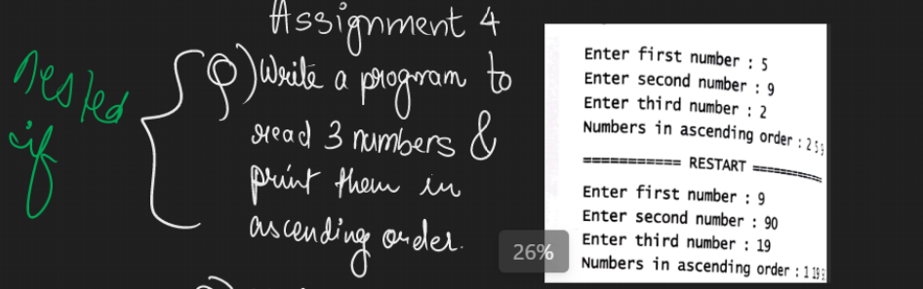

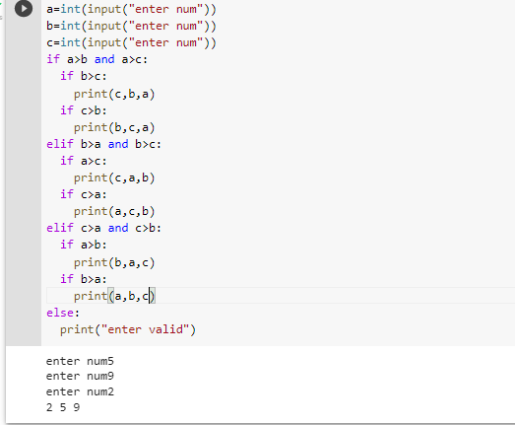

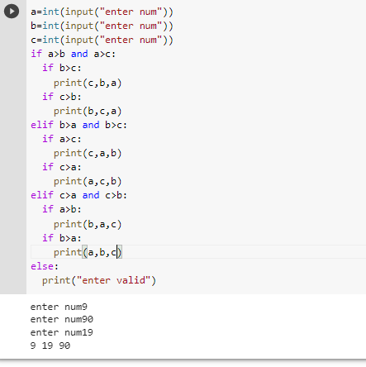

Q2) 